**PRACTICAL FILE**

**NAME** - KULVINDER BIDHURI

**PROGRAM** - BCA(AI&ML)

**ROLL NO**.- 34

**GROUP**- 1

**Q1). Create a simple html page using basic tags.**

<html>

<head>

<title> Tags </title>

</head>

<body>

<h4>Tags</h4>

</body>

</html>

**OUTPUT-**

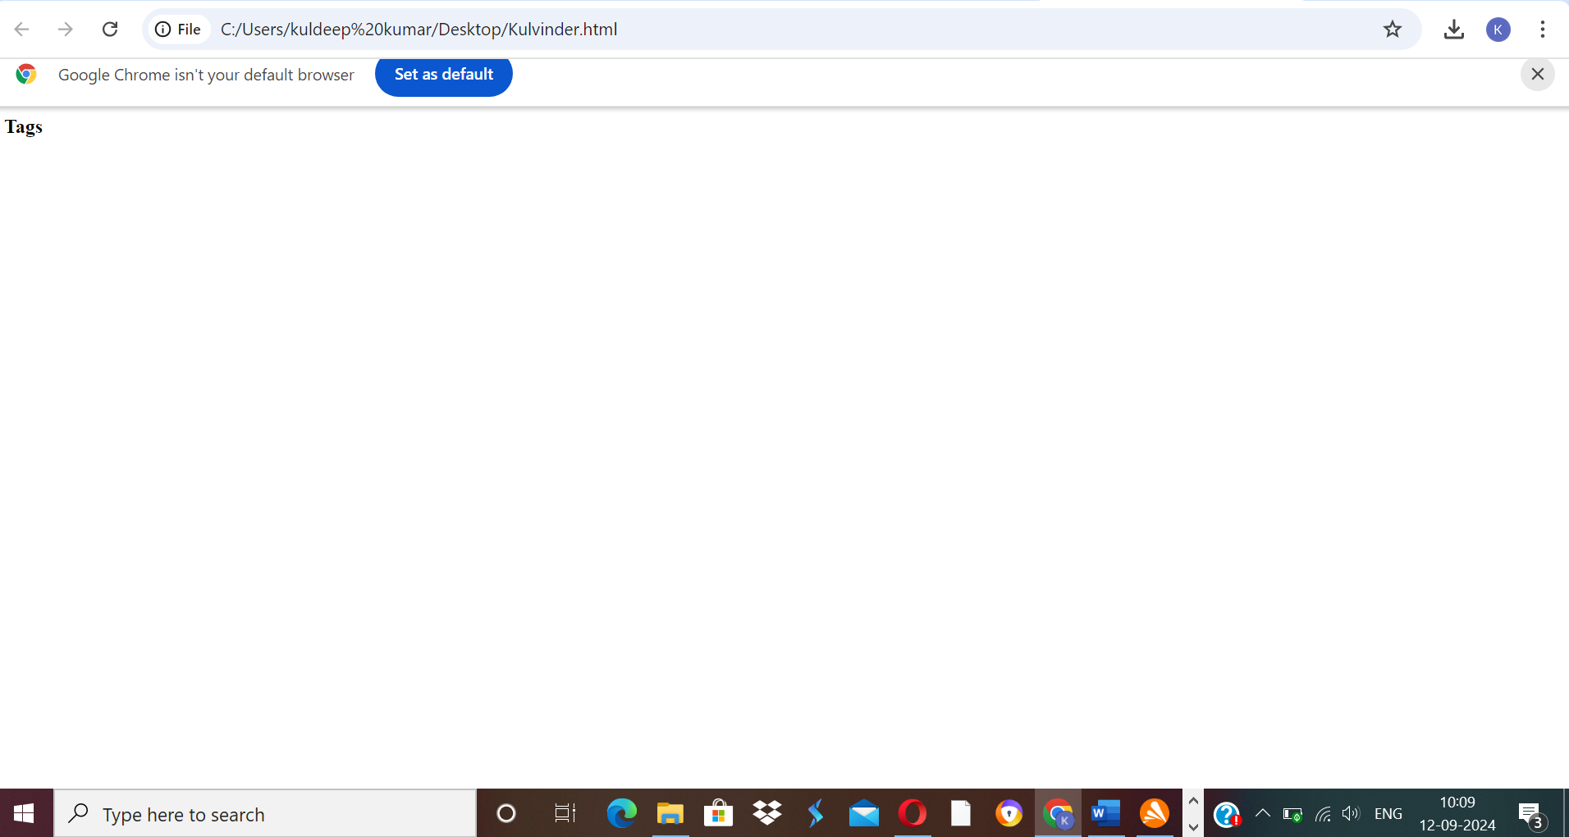

**Q2). Create a web page that displays your name to the screen.**

<html>

<head>

<title> Kulvinder </title>

</head>

<body>

<h4> Student Name - Kulvinder bidhuri</h4>

</body>

</html>

**OUTPUT-**

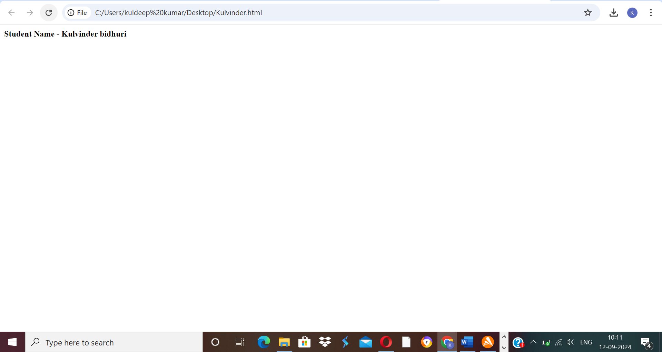

**Q3). Create a web page and show the output from 1 to 10 in separate lines.**

<html>

<head>

<title> Student Information </title>

</head>

<body>

<h4> Student Name - kulvinder bidhuri </h4>

<p> 1 </p>

<p> 2 </p>

<p> 3 </p>

<p> 4 </p>

<p> 5 </p>

<p> 6 </p>

<p> 7 </p>

<p> 8 </p>

<p> 9 </p>

<p> 10 </p>

</body>

</html>

**OUTPUT-**

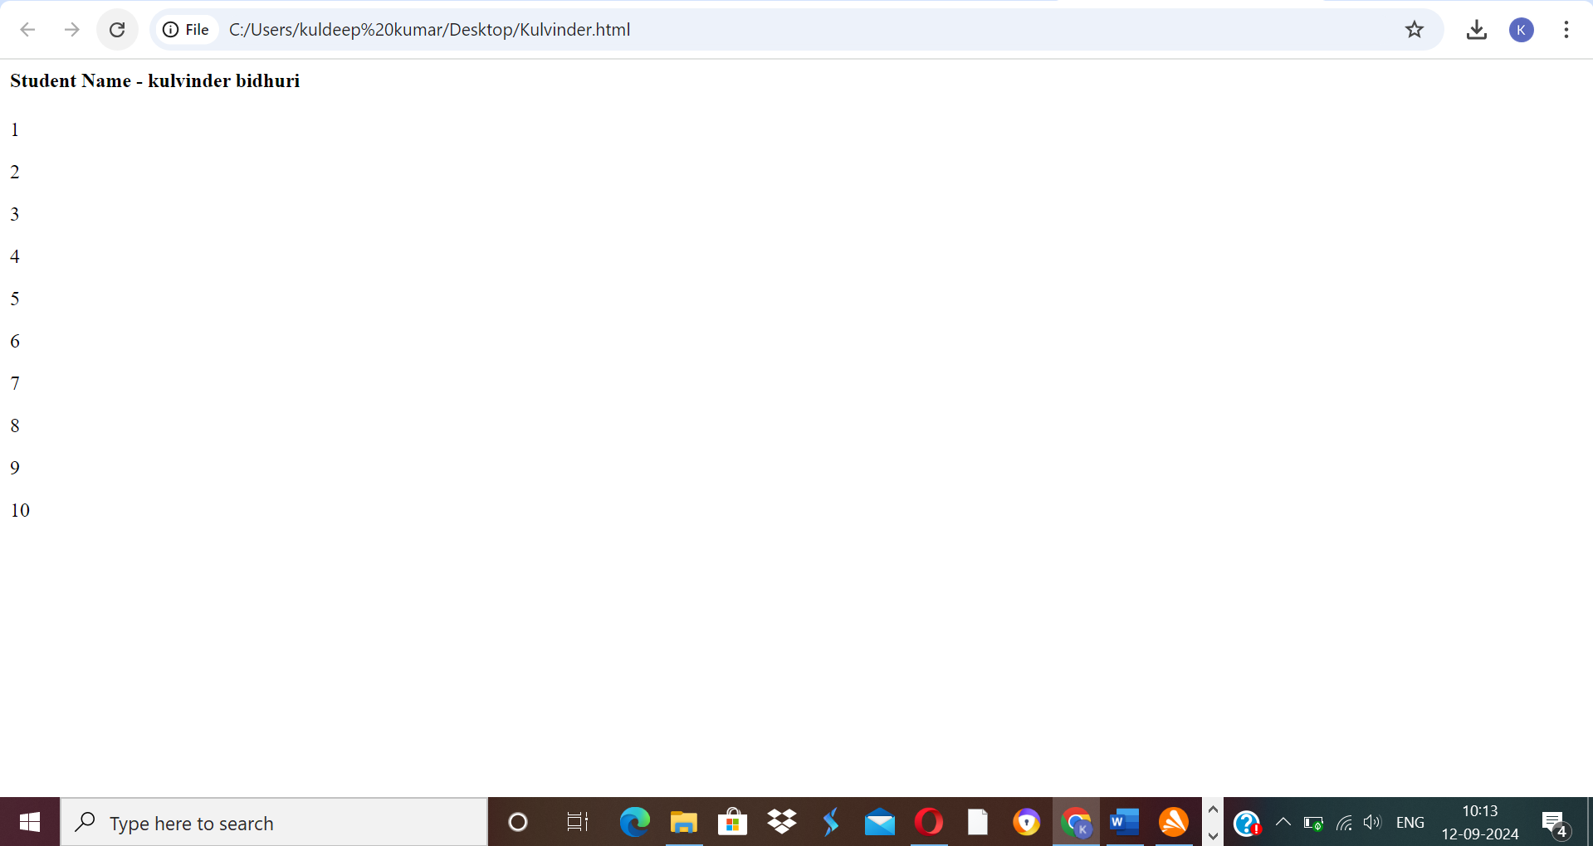

**Q4)Create a web page and show the output from 1 to 10 in separate lines, each number being in different colour.**

<html>

<head>

<title> Student Information </title>

</head>

<body style="background-color:powderblue;">

<h4 style="background-color:Tomato;"> Student Name - kulvinder bidhuri</h4>

<p style="color:red;"> 1 </p>

<p style="color:purple;"> 2 </p>

<p style="color:orange;"> 3 </p>

<p style="color:pink;"> 4 </p>

<p style="color:green;"> 5 </p>

<p style="color:blue;"> 6 </p>

<p style="color:brown;"> 7 </p>

<p style="color:yellow;"> 8 </p>

<p style="color:violet;"> 9 </p>

<p style="color:black;"> 10 </p>

</body>

</html>

**OUTPUT-**

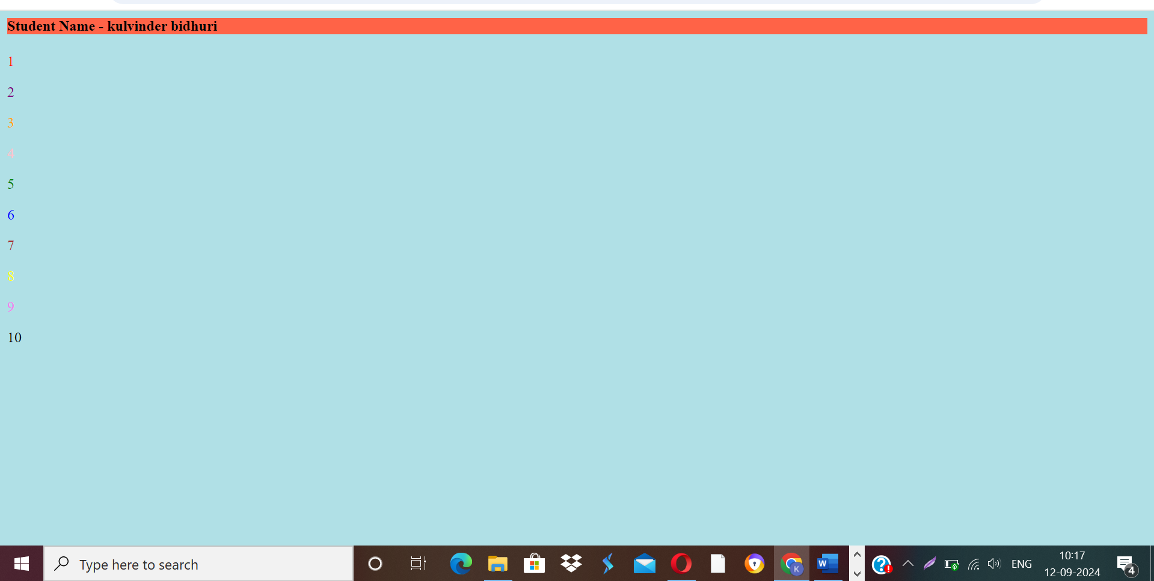

**Q5). How do I make a picture as a background on my web pages?**

<html>

<head>

<title> Student Information </title>

</head>

<body style="background-color:powderblue;">

<h3 style="color:Tomato;"> Adding picture to background </h3>

<img src="https://encrypted-tbn0.gstatic.com/images?q=tbn:ANd9GcQEc9A_S6BPxCDRp5WjMFEfXrpCu1ya2OO-Lw&s">

</body>

</html>

**OUTPUT-**

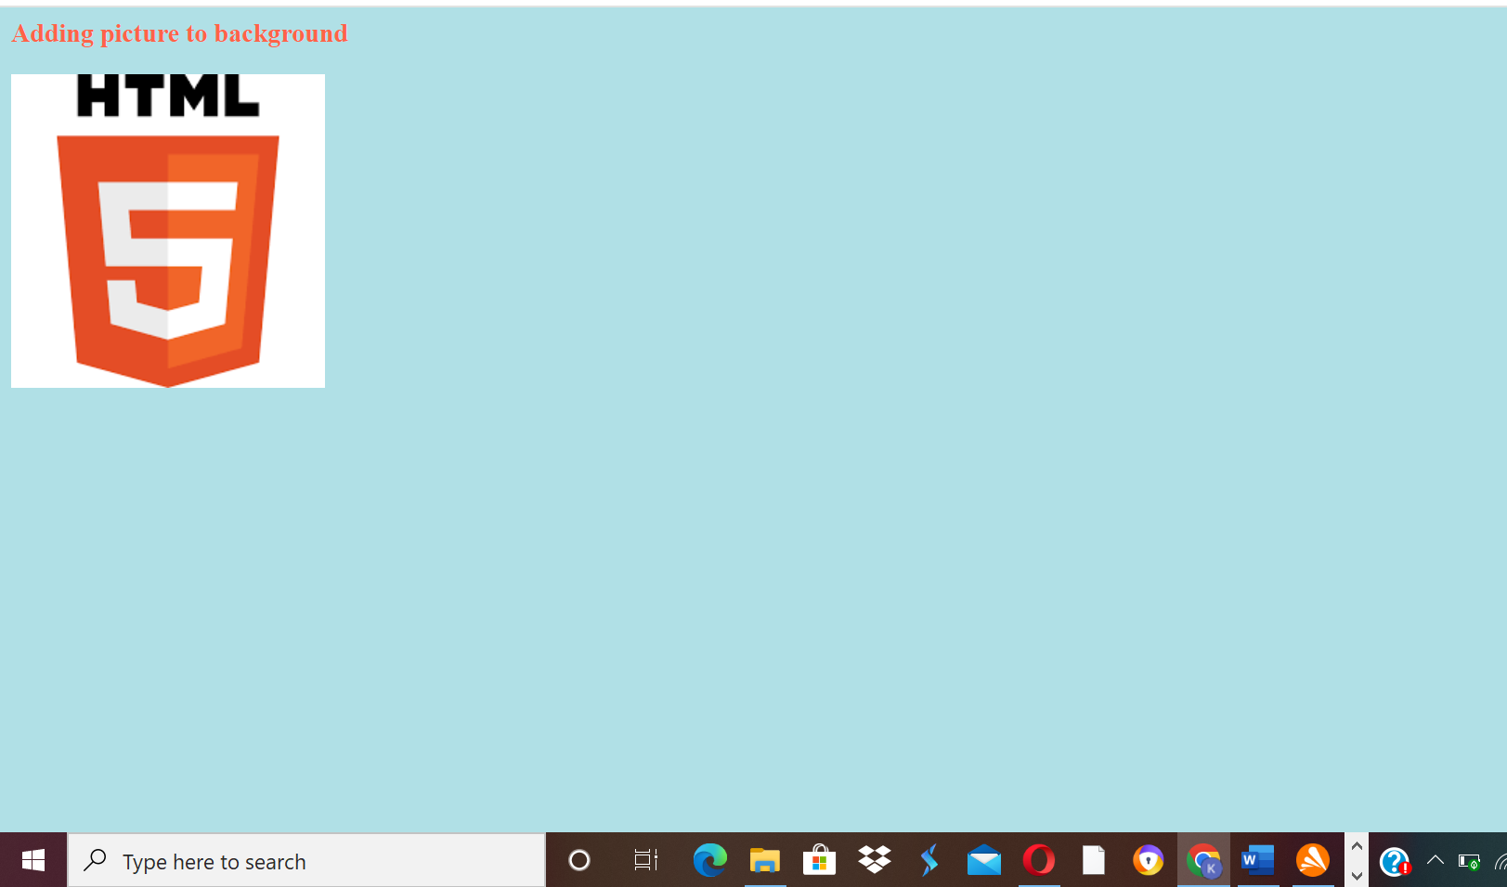

**Q6)Create a web page to print paragraph with 4-5 snetences, each sentence shall have a different font.**

<html>

<head>

<title> Student Information </title>

</head>

<body style="background-color:powderblue;">

<h5 style="Font-Family:Cursive;"> This is Paragraph one </h5>

<h4 style="Font-Family:Fantasy;"> This is Paragraph two </h4>

<h3 style="Font-Family:Helvetica;"> This is Paragraph three </h3>

<h2 style="Font-Family:Courier New;"> This is Paragraph four </h2>

<h1 style="Font-Family:Verdana New;"> This is Paragraph five</h1>

</body>

</html>

**OUTPUT-**

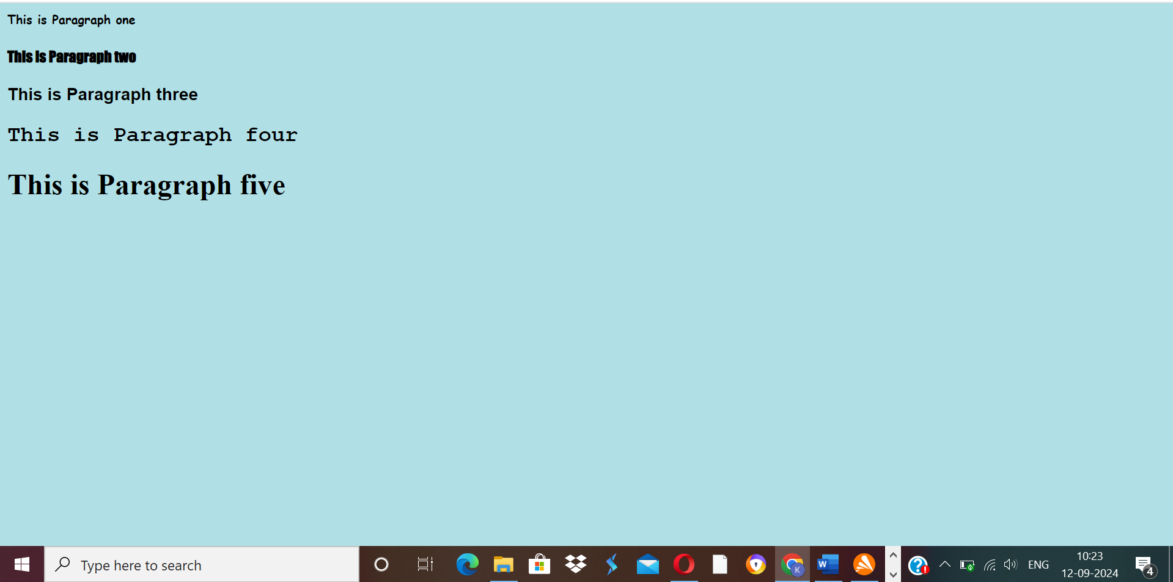

**Q7)Write HTML code to print a paragraph that is descriptions of a book, it shall include the title of book, its author name; name and title should be underlined and all adjactives shall be bold and italics**.

<html>

<head>

<title> Student Information </title>

</head>

<body style="background-color:powderblue;">

<p>Book name - <b><u><i> Harry Potter and the Philosopher's Stone</b></u></i> Author name - <b><u><i>J. K. Rowling</b></u></i></p>

</body>

</html>

**OUTPUT-**

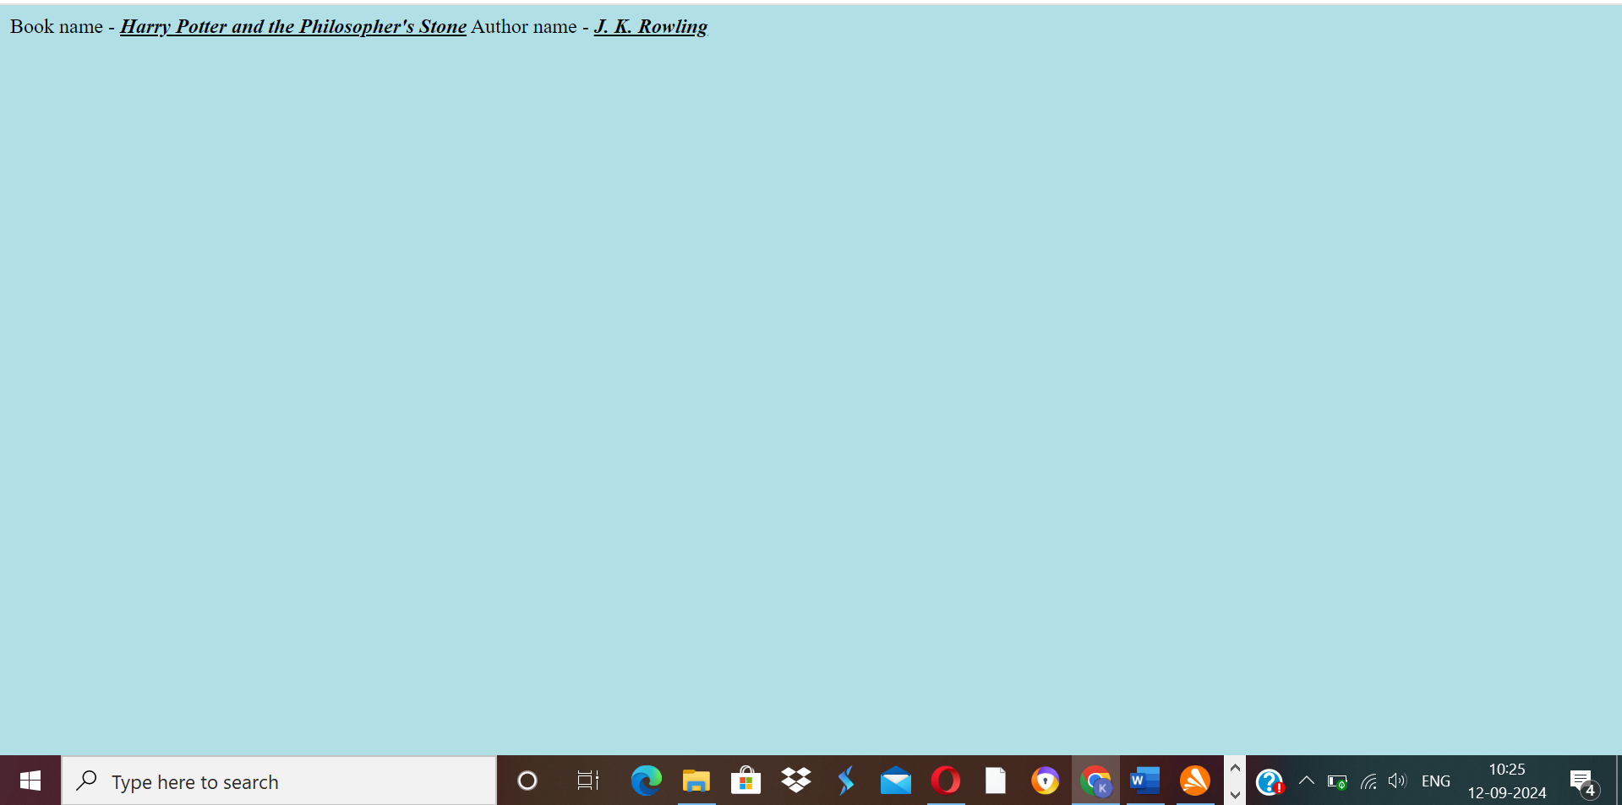

**Q8)Write HTML code to print your name using heading tags, every letter shall be of different heading size.**

<html>

<head>

<title> Heading Tag </title>

</head>

<body style="background-color:powderblue;">

<h1>K</h1>

<h2>U</h2>

<h3>L</h3>

<h4>V</h4>

<h5>I</h5>

<h6>N</h6>

<h1>D</h1>

<h2>E</h2>

<h3>R</h3>

</body>

</html>

Output -

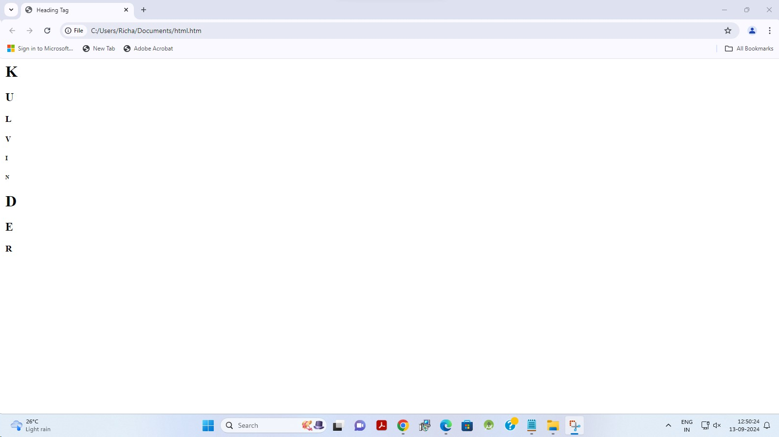

**Q9)Write HTML code to print the sequence of number 1-20. Each number shall be in different line with number 2 next to it as subscript, an equal sign and result.**

<html>

<head>

<title> Heading Tag </title>

</head>

<body style="background-color:powderblue;">

<p>1<sub>2</sub> = 2</p>

<p>2<sub>2</sub> = 4</p>

<p>3<sub>2</sub> = 6</p>

<p>4<sub>2</sub> = 8</p>

<p>5<sub>2</sub> = 10</p>

<p>6<sub>2</sub> = 12</p>

<p>7<sub>2</sub> = 14</p>

<p>8<sub>2</sub> = 16</p>

<p>9<sub>2</sub> = 18</p>

<p>10<sub>2</sub> = 20</p>

<p>11<sub>2</sub> = 22</p>

<p>12<sub>2</sub> = 24</p>

<p>13<sub>2</sub> = 26</p>

<p>14<sub>2</sub> = 28</p>

<p>15<sub>2</sub> = 30</p>

<p>16<sub>2</sub> = 32</p>

<p>17<sub>2</sub> = 34</p>

<p>18<sub>2</sub> = 36</p>

<p>19<sub>2</sub> = 38</p>

<p>20<sub>2</sub> = 40</p>

</body>

</html>

Output-

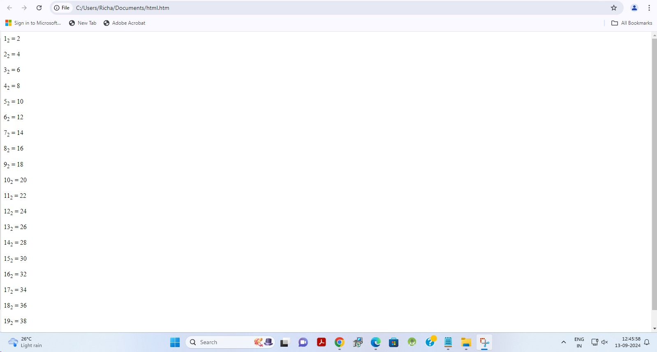

**Q10). Write HTML code to display an image with border of size with width 200, height 200 pixel, leaving H space and V space of your choice with image hanging in the right side on the screen.**

Input -

<html>

<head>

<title>Image Example</title>

</head>

<body>

<img src="https://tse4.mm.bing.net/th/id/OIP.MgfkQ80RdbrN8tPQWvmWpAHaEK?rs=1&pid=ImgDetMain" width="200" height="200" style="border: 5px solid black;" align="right">

</body>

</html>

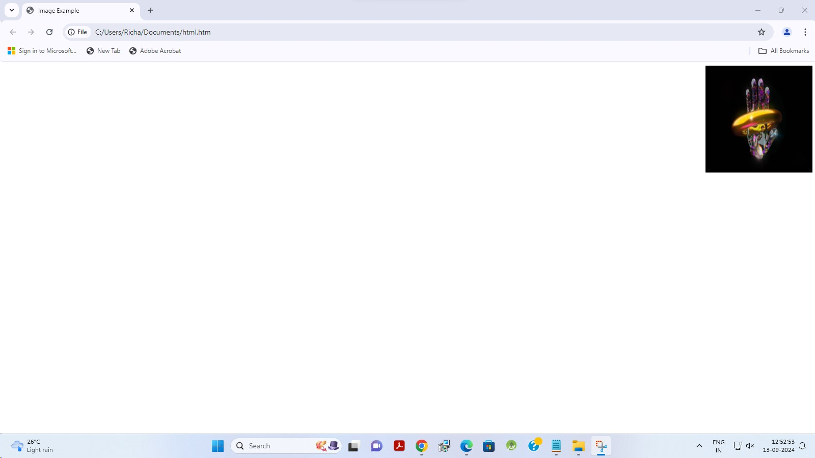

**Q11). Write HTML code to create a web page with heading. The heading shall be displayed at the top-center of the page and the image shall be at the center, just below the heading**

Input -   
  
<html>

<head>

<title>Web Page with Centered Heading and Image</title>

</head>

<body>

<h1 style="text-align: center;">Heading</h1>

<div style="text-align: center;">

<img src="https://tse4.mm.bing.net/th/id/OIP.MgfkQ80RdbrN8tPQWvmWpAHaEK?rs=1&pid=ImgDetMain" width="200" height="200" alt="Centered Image">

</div>

</body>

</html>

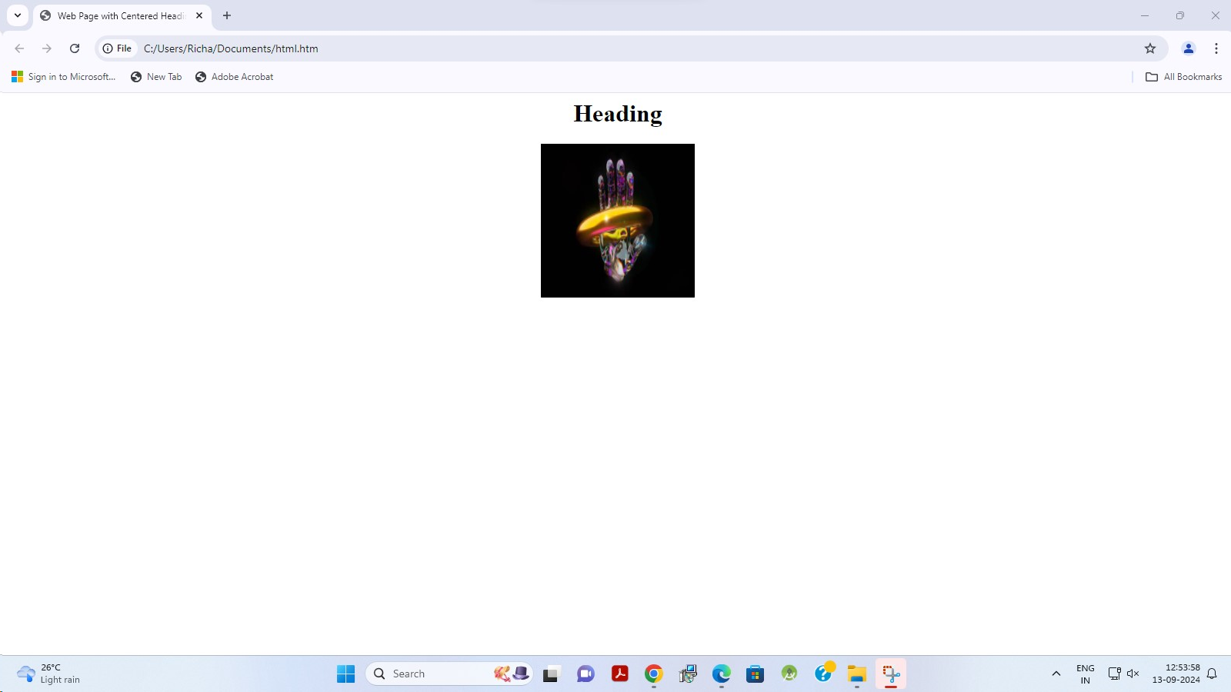

**Q12. Write HTML code using Multimedia tags.**

**Ans.<HTML>**

**<HEAD>**

**<TITLE>kulvinder bidhuri</TITLE>**

**</head>**

**<body>**

**<h1 align="center">MULTIMEDIA</H1>**

**<hr>**

**<video src="C:\Users\kulvinder\OneDrive\Pictures/jungle.mp4" controls="controls" width="720" height="480">**

**</video>**

**<br>**

**<audio src="C:\Users\kulvinder\OneDrive\Pictures/nightforest.mp3" controls="controls" autoplay="autoplay">**

**</BODY>**

**</HTML>**

**OUTPUT –**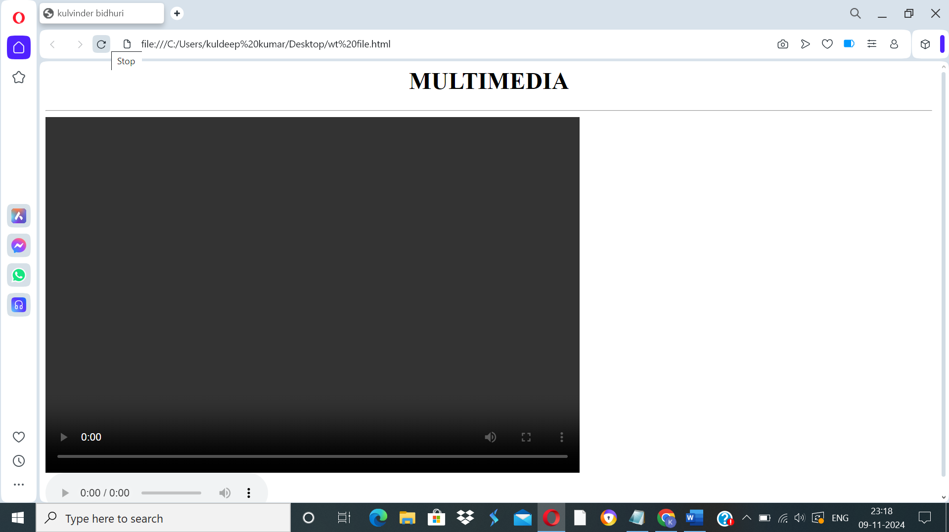

**Q13. Create a Table using Rowspan and Colspan taking example of student record.**

**Ans.**<HTML>

<HEAD>

<TITLE>kulvinder bidhuri</TITLE>

</head>

<body>

<table width="500"height="100"border="2px">

<tr>

<th colspan="2">name</th>

<th>class</th>

<th>school</th>

</tr>

<tr>

<td rowspan="2">kulvinder</td>

<td rowspan="2">bidhuri</td>

<td>12</td>

<td rowspan="2">SDV</td>

</tr>

<tr>

<td>A</td>

</tr>

<tr>

<td rowspan="2">yash</td>

<td rowspan="2">krishna</td>

<td>12</td>

<td rowspan="2">SDV</td>

</tr>

<tr>

<td>A</td>

</tr>

<tr>

<td rowspan="2">vansh</td>

<td rowspan="2">arora</td>

<td>12</td>

<td rowspan="2">SDV</td>

</tr>

<tr>

<td>A</td>

</tr>

</table>

</BODY>

</HTML>

**OUTPUT-**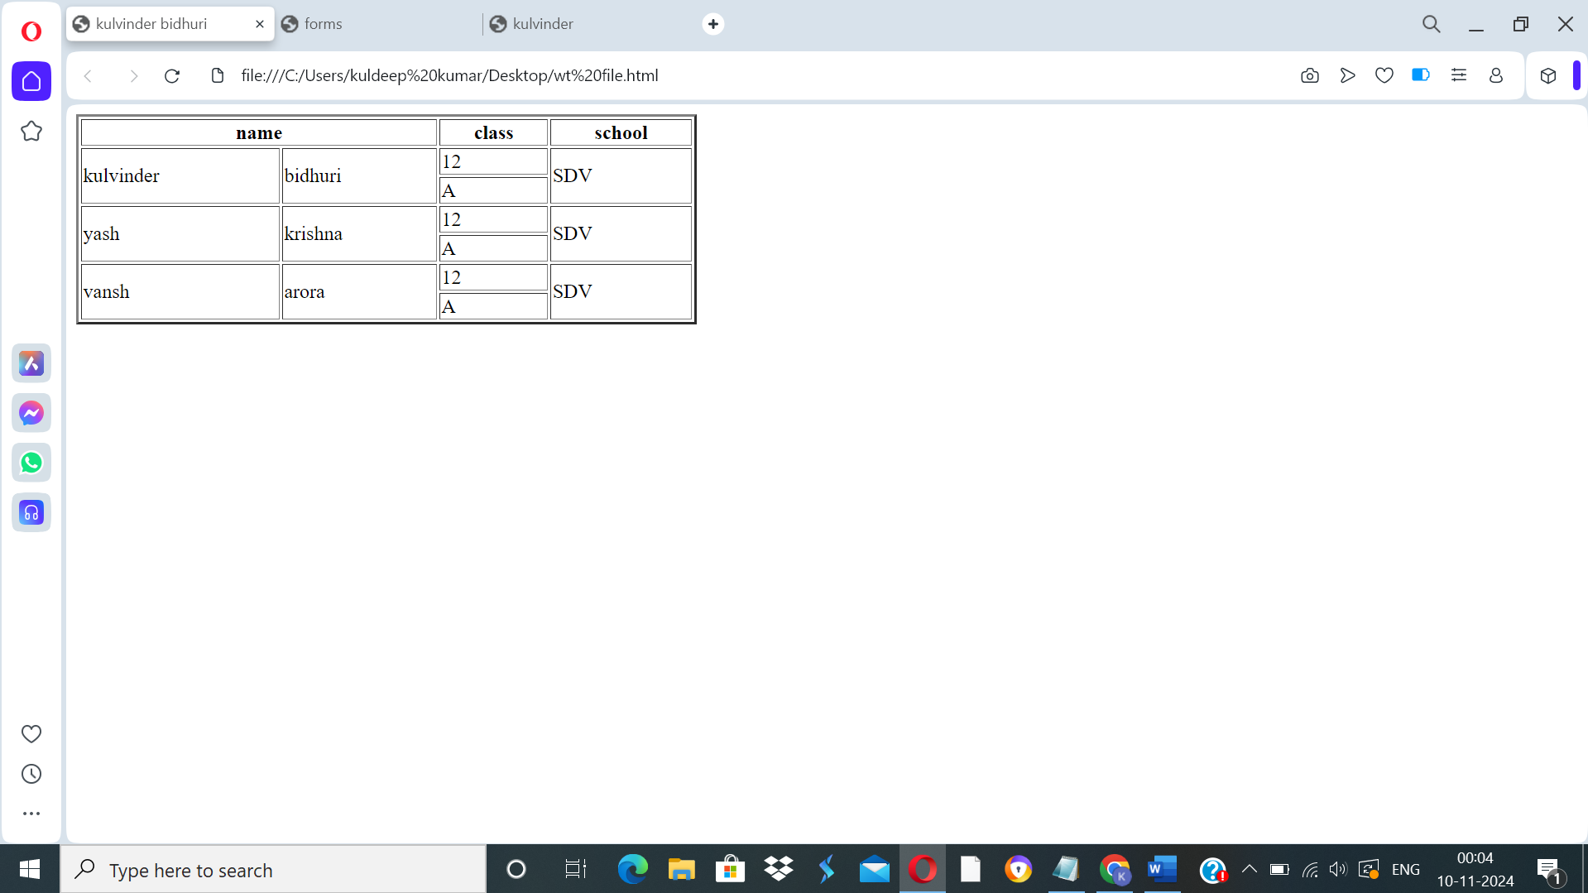

**Q14. Write HTML code using table tags <TABLE> and cellpadding and cell spacing as its attributes.**

**ANS.**

**<html>**

**<head>**

**</head>**

**<body>**

**<table border="2pt" cellspacing="5pt" cellpadding="5pt">**

**<tr>**

**<th>S.no</th>**

**<th>Roll no.</th>**

**<th>Name</th>**

**<th>Address</th></tr>**

**<tr>**

**<td>1</td>**

**<td>001</td>**

**<td>kulvinder</td>**

**<td>delhi</td></tr>**

**<tr>**

**<td>2</td>**

**<td>002</td>**

**<td>kartik</td>**

**<td>delhi</td></tr>**

**<tr>**

**<td>3</td>**

**<td>003</td>**

**<td>yash</td>**

**<td>gurgaon</td></tr>**

**</table>**

**</body>**

**</html>**

**OUTPUT –** 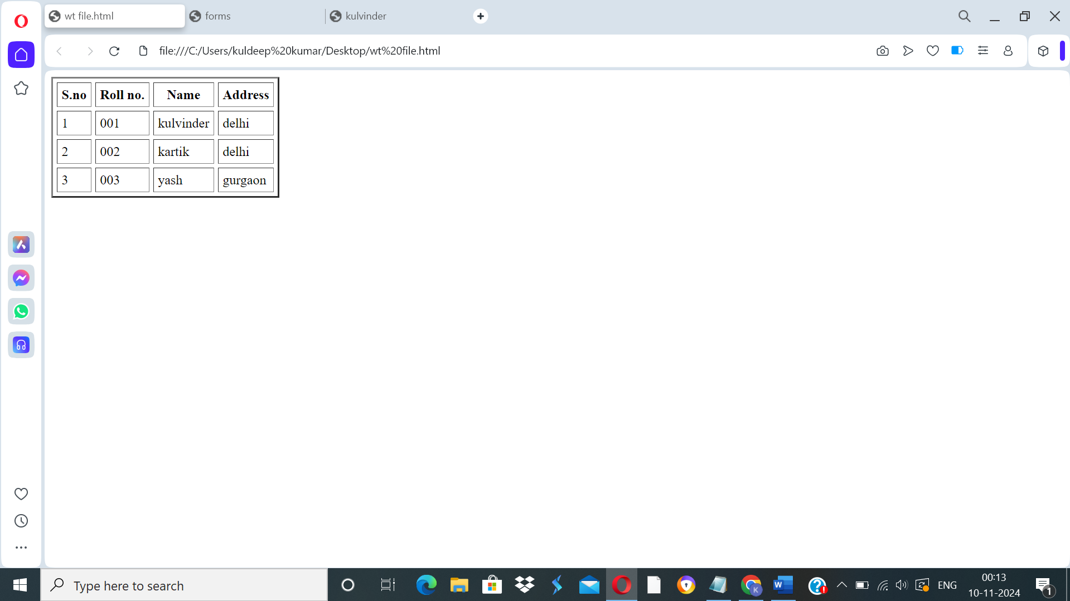

**Q15. Create unordered, ordered and definition lists taking example of your subjects in MCA, IST, Iind and IIIrd semester.**

**ANS.**

**html>**

**<head>**

**<title>kulvinder bidhuri</title>**

**</head>**

**<body>**

**<h2> Subjects in BCA sem 1</h3>**

**<ol>**

**<li>Web technologies</li>**

**<li>Introduction to IT & programming in C</li>**

**<li>Mathematics</li>**

**<li>DBMS</li>**

**<li>SDGs</li>**

**<li>IKS</li>**

**<li>CDCs</li>**

**</ol>**

**<h2> Sunject in BCA sem 2 </h2>**

**<ul>**

**<li>COMMUNICATION</li>**

**<li>DATA STRUCTURE</li>**

**<li>JAVA</li>**

**<li>OPERATING SYSTEM</li>**

**<li>STATICS FOR BCA</li>**

**</ul>**

**<h2>Subjects in BCA Sem 3</h2>**

**<dl>**

**<dt>C++</dt>**

**<dt>COMPUTER ARCHITECTURE</dt>**

**<dt>BUSINESS ECONOMICS</dt>**

**<dt>ELEMENT OF STATICS</dt>**

**<dt>DSA OF C++</dt>**

**</dl>**

**</body>**

**</html>**

**OUTPUT –**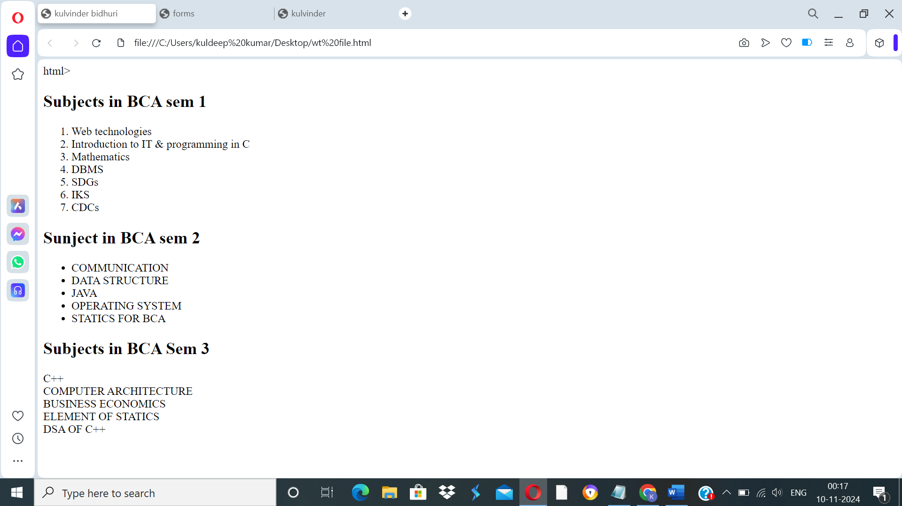

**Q16. Write HTML code using <frameset> and <frame> tag with all its attributes.**

**ANS. <html>**

**<head>**

**<title>Frameset Example</title>**

**</head>**

**<frameset rows="50%,50%" frameborder="1" bordercolor="black" framespacing="5">**

**<frame src="https://www.example.com" name="topFrame" scrolling="yes" noresize="noresize" target="_self" />**

**<frame src="https://www.example.org" name="bottomFrame" scrolling="auto" noresize="noresize" target="_self" />**

**</frameset>**

**<noframes>**

**<body>**

**<p>Your browser does not support frames. Please update your browser.</p>**

**</body>**

**</noframes>**

**</html>**

**OUTPUT-** 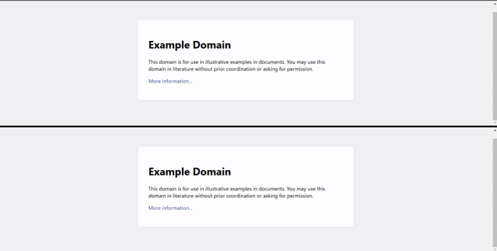

**Q17. Write HTML code to design a form in HTML using controls and buttons such as Textbox, Text area,**

**password, submit button, browse button, drop-down menu.**

**ANS.**

**<html>**

**<head>**

**<title>kulvinder bidhuri</title>**

**</head>**

**<body>**

**<h1>Registration Form</h1>**

**<form action="submit.php" method="post" enctype="multipart/form-data">**

**<label for="name">Name:</label>**

**<input type="text" id="name" name="name" required><br><br>**

**<label for="email">Email:</label>**

**<input type="email" id="email" name="email" required><br><br>**

**<label for="password">Password:</label>**

**<input type="password" id="password" name="password" required><br><br>**

**<label for="profile_pic">Photograph:</label>**

**<input type="file" id="profile_pic" name="profile_pic"><br><br>**

**<label for="country">Country:</label>**

**<select id="country" name="country">**

**<option value="india">India</option>**

**<option value="usa">USA</option>**

**<option**

**value="uk">UK</option>**

**</select><br><br>**

**<label for="message">Message:</label>**

**<textarea id="message" name="message" rows="5" cols="30"></textarea><br><br>**

**<input type="submit" value="Submit">**

**<input type="reset" value="Reset"><br><br>**

**</form>**

**</body>**

**</html>**

**OUTPUT –**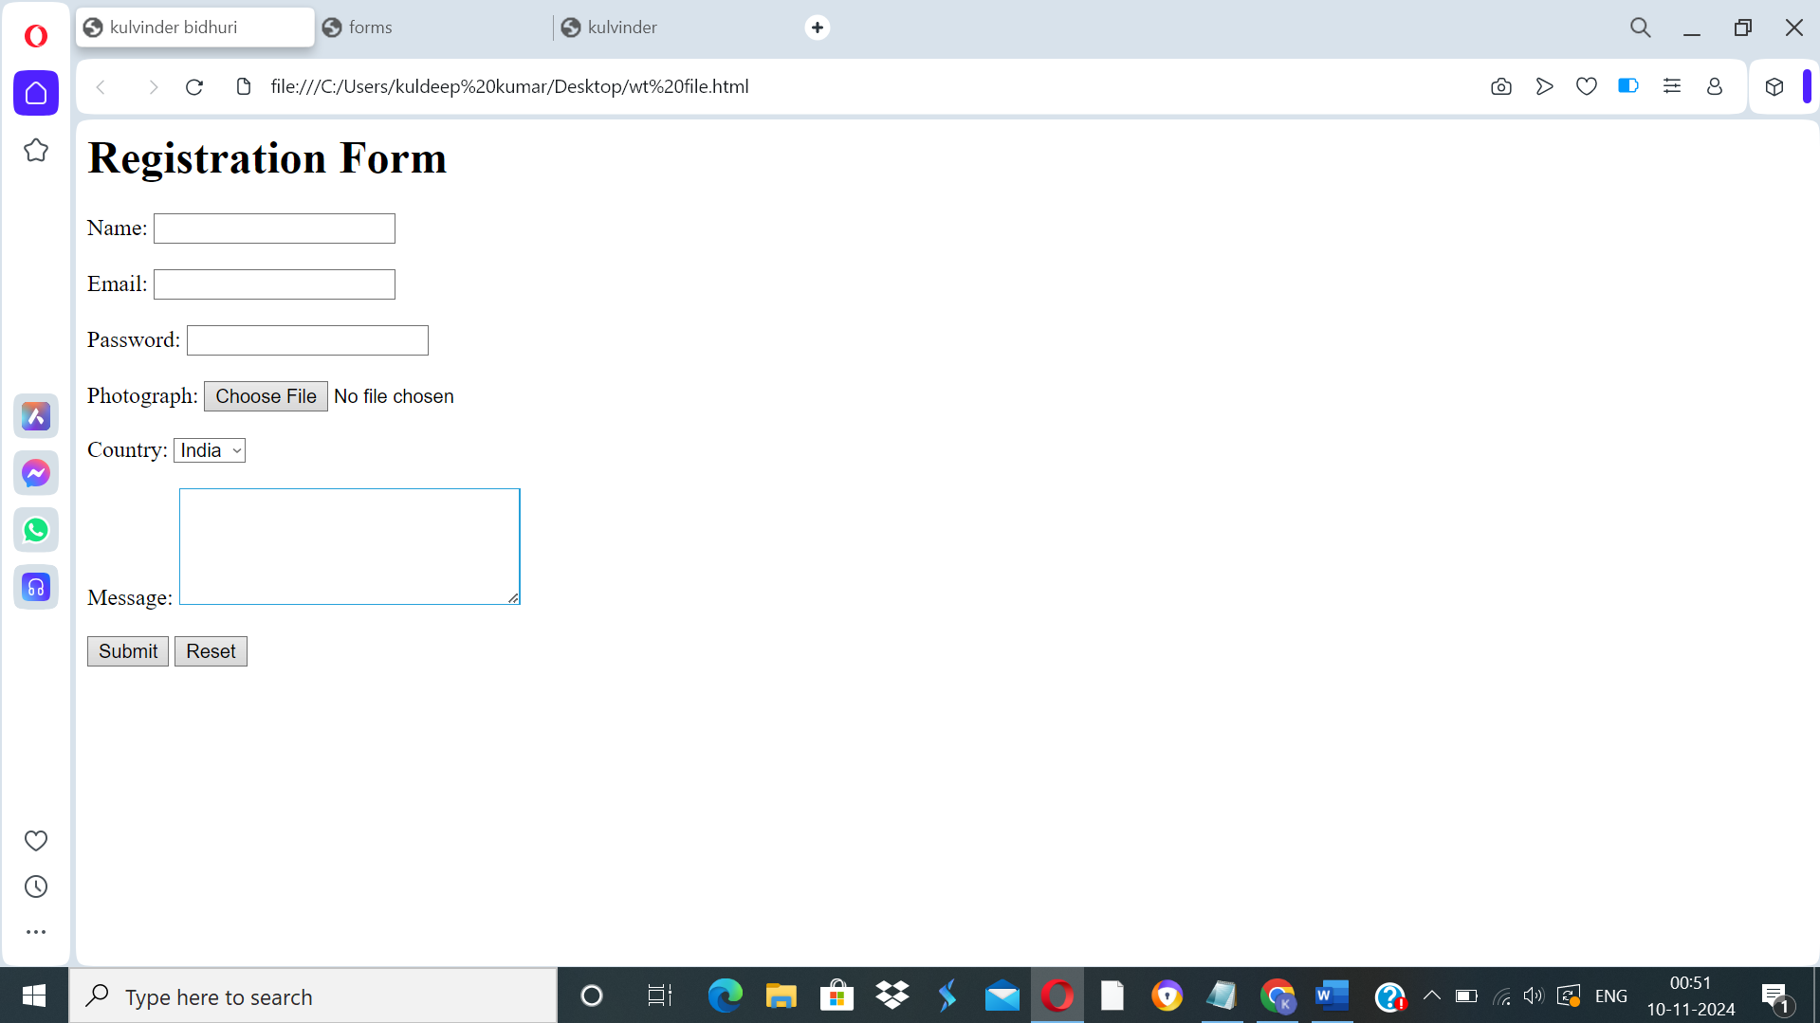

**Q18. Write HTML code to design a registration form in html.**

**ANS.**

**<html>**

**<head>**

**<title>kulvinder bidhuri</title>**

**</head>**

**<body>**

**<h1>SPORTS REGISTRATION FORM</h1>**

**<form action="submit.php" method="post">**

**<label for="first_name">Participant Name</label><br>**

**<input type="text" id="first_name" name="first_name" placeholder="First"><br>**

**<input type="text" name="last_name" placeholder="Last"><br><br>**

**<lable for="date" name="birth">DOB:</lable>**

**<input type="date" max="2007" min="2003" required/><br><br>**

**<label for="gENDER">GENDER</label><br>**

**<select id="GENDER" name="GENDER">**

**<option value="">Please select</option>**

**<option value="MALE">MALE</option>**

**<option value="FEMALE">FEMALE</option>**

**</select><br><br>**

**<label for="school_district">School District</label><br>**

**<input type="text" id="school_district" name="school_district"><br><br>**

**<label for="shirt_size">Shirt Size</label><br>**

**<select id="shirt_size" name="shirt_size">**

**<option value="">Please select</option>**

**<option value="s">Small</option>**

**<option value="m">Medium</option>**

**<option value="l">Large</option>**

**<option value="xl">Extra Large</option>**

**</select><br><br>**

**<label for="parent_first_name">Parent Name</label><br>**

**<input type="text" id="parent_first_name" name="parent_first_name" placeholder="First"><br>**

**<input type="text" name="parent_last_name" placeholder="Last"><br><br>**

**<label for="emergency_contact">Emergency Contact</label><br>**

**<input type="text" id="emergency_contact" name="emergency_contact"><br><br>**

**<input type="submit" value="Submit">**

**</form>**

**</body>**

**</html>**

**OUTPUT –**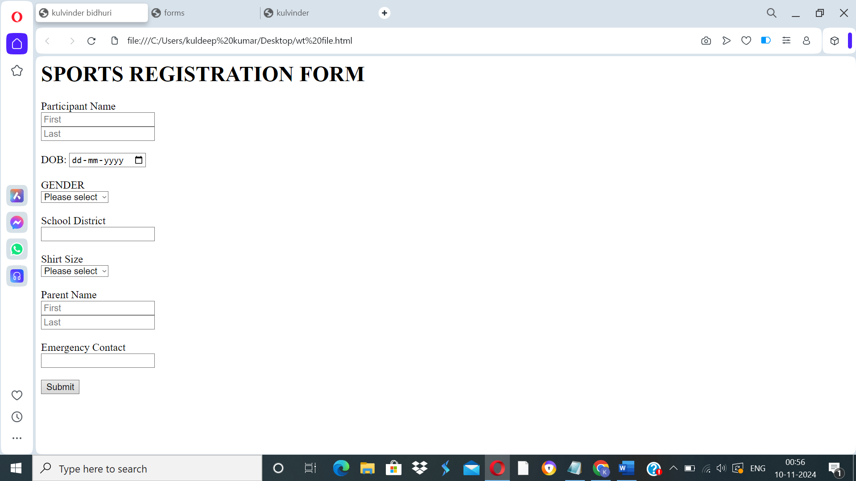

**Q19. Write a HTML code to design a student admission form in html.**

**ANS. <html>**

**<head>**

**<title>Student Admission Form</title>**

**</head>**

**<body>**

**<h1>Student Registration Form</h1>**

**<form action="submit.php" method="post">**

**<label for="student_name">Student Name</label>**

**<input type="text" id="student_name" name="student_name" required><br><br>**

**<label for="date_of_birth">Date of Birth</label>**

**<input type="date" id="date_of_birth" name="date_of_birth" required><br><br>**

**<label**

**for="gender">Gender</label>**

**<input type="radio" id="male" name="gender" value="male">**

**<label for="male">Male</label>**

**<input type="radio" id="female"**

**name="gender" value="female">**

**<label for="female">Female</label><br><br>**

**<label for="address">Address</label><br>**

**<textarea id="address" name="address"**

**rows="5" cols="30" required></textarea><br><br>**

**<label for="phone_number">Phone Number</label>**

**<input type="tel" id="phone_number" name="phone_number" required><br><br>**

**<label for="email">Email</label>**

**<input type="email" id="email" name="email" required><br><br>**

**<label for="cOURSE">COURSE</label>**

**<select id="cOURSE" name="cOURSE" required>**

**<option value="1">BCA</option>**

**<option value="2">LAW</option>**

**<option value="3">B.COM</option>**

**<option value="4">B.TECH</option>**

**<option value="5">BBA</option>**

**</select><br><br>**

**<label for="guardian name">Guardian Name</label>**

**<input type="text" id="guardian name" name="guardian name" required>**

**<label for="guardian contact">Guardian Contact</label>**

**<input type="number" id="guardian contact" name="guardian contact" required><br><br>**

**<label for="10TH MARKSHEET">10TH Marksheet</label>**

**<input type="file"><br><br>**

**<label for="12TH MARKSHEET">12TH Marksheet</label>**

**<input type="file"><br><br>**

**<label for="migration_certificate">Migration Certificate</label>**

**<input type="file"><br><br>**

**<label for="Character_certificate">Character Certificate</label>**

**<input type="file"><br><br>**

**<input type="submit" value="Submit">**

**</form>**

**</body>**

**</html>**

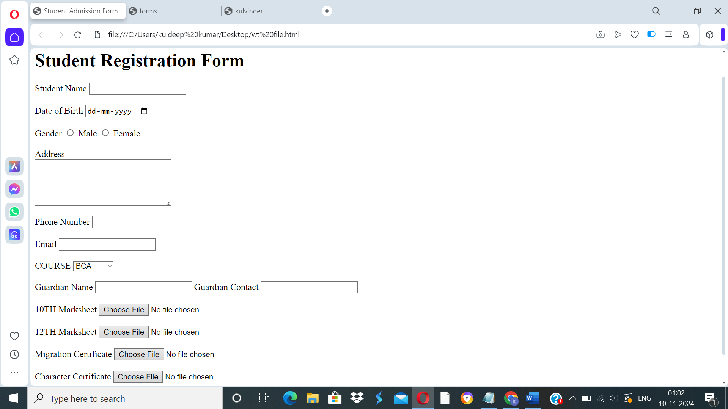

**OUTPUT –**

**Q20. Create a home page of your own using any component and style.**

**ANS.**

**<html>**

**<head>**

**<style>**

**H1, h2, h3 {**

**text-align: LEFT;**

**color:orange;**

**}**

**#para1 {**

**text-align: center;**

**color: Blue;**

**font-size:20;**

**}**

**.center{text-align: center;**

**color: Green;**

**font-size:30;**

**font-family: sans-serif;**

**}**

**</style>**

**</head>**

**<body bgcolor="red">**

**<H1> CSS</h1>**

**<h2> Use to style an HTML document </h2>**

**<p id="para1">CSS save alot of work as it can control the layout of multiple web pages all at once </p>**

**<p class="center"> External stylesheet are stored in CSS file</p>**

**<hr>**

**</body>**

**</html>**

**OUTPUT –**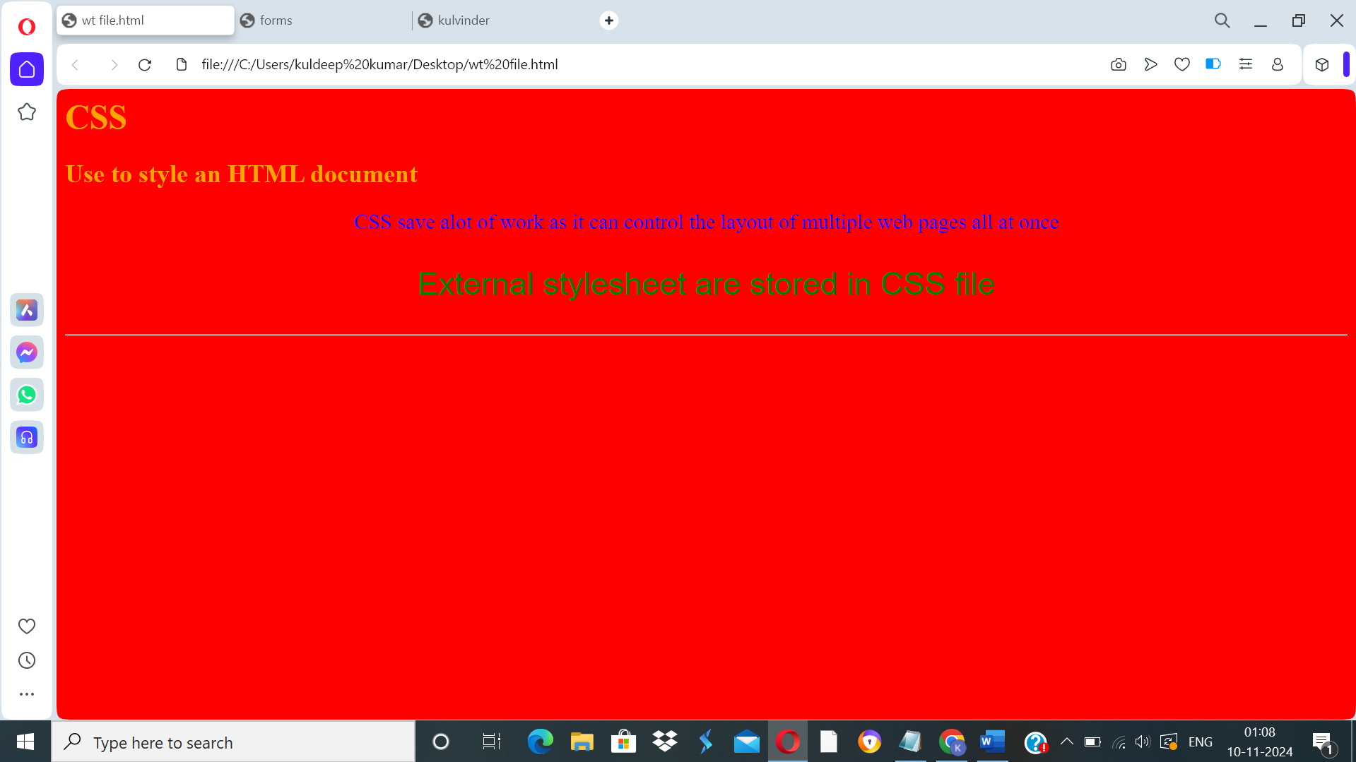

**Question 21) Write HTML code for including Local hyperlinking in a web page.**

<html>

<head>

<meta charset="UTF-8">

<meta name="viewport" content="width=device-width, initial-scale=1.0">

<title>Local Hyperlinking Example</title>

</head>

<body>

<h1>Welcome to My Web Page</h1>

<p>Click the links below to jump to different sections of the page:</p>

<ul>

<li><a href="#section1">Go to Section 1</a></li>

<li><a href="#section2">Go to Section 2</a></li>

<li><a href="#section3">Go to Section 3</a></li>

</ul>

<div id="section1">

<h2>Section 1</h2>

<p>This is the first section of the page.</p>

</div>

<div id="section2">

<h2>Section 2</h2>

<p>This is the second section of the page.</p>

</div>

<div id="section3">

<h2>Section 3</h2>

<p>This is the third section of the page.</p>

</div>

</body>

</html>

**Output-**

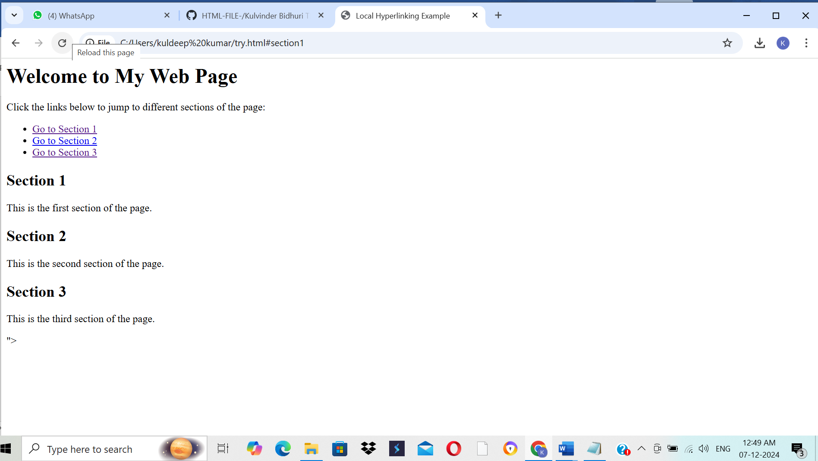

**Question 22) Write HTML code for including Inter hyperlinking in a web page.**

**INPUT-**

<html>

<head>

<title>Link to Another Page</title>

</head>

<body>

<h1>Welcome to the Homepage</h1>

<nav>

<ul>

<li><a href="about.html">About Us</a></li>

<li><a href="services.html">Our Services</a></li>

<li><a href="contact.html">Contact Us</a></li>

</ul>

</nav>

</body>

</html>

**Output-**

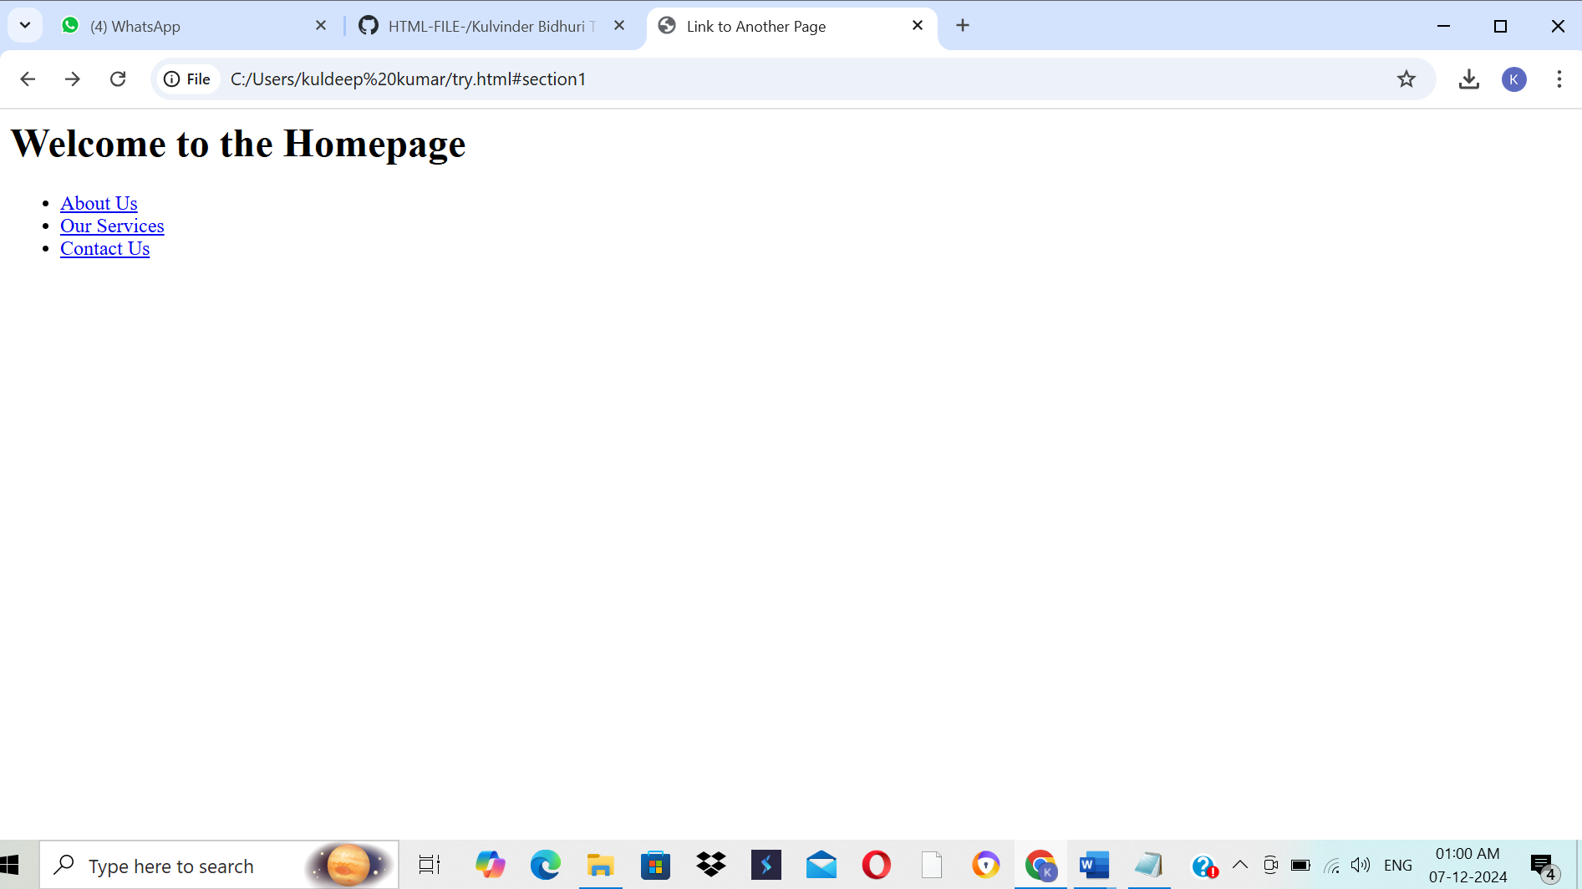

**Question 23) Write HTML code for including External hyperlinking in a web page**

**INPUT-**

<html>

<head>

<title>External Link Example</title>

</head>

<body>

<h1>Welcome to My Web Page</h1>

<p>Click the link below to visit an external website:</p>

<a href="https://www.example.com" target="_blank">Visit Example.com</a>

</body>

</html>

**Output-**

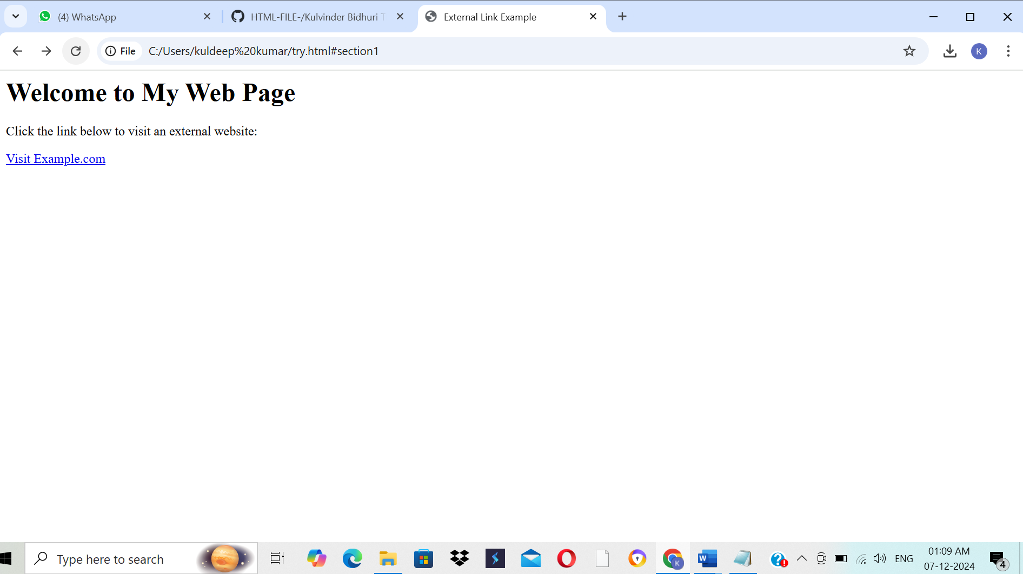

**Question 24) Write code to show External CSS with HTML code**

**INPUT-**

<html>

<head>

<title>External CSS Example</title>

<link rel="stylesheet" href="styles.css">

</head>

<body>

<h1>Hello, World!</h1>

<p>This is an example of an HTML document styled with external CSS.</p>

<button>Click Me!</button>

</body>

</html>

**Output-**

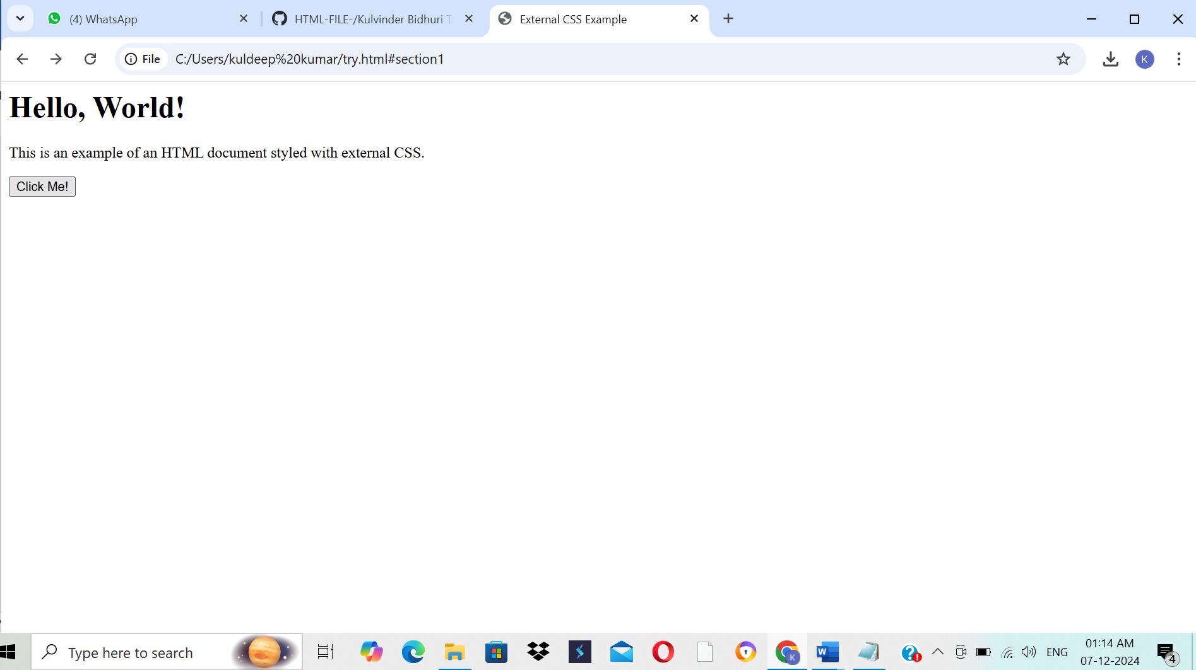

**Question 25) Write code to show Internal CSS with HTML code.**

**INPUT-**

<html>

<head>

<title>Internal CSS Example</title>

<style>

body {

font-family: Arial, sans-serif;

background-color: #f4f4f9;

margin: 0;

padding: 0;

}

h1 {

color: #333;

text-align: center;

margin-top: 20px;

}

p {

color: #555;

font-size: 18px;

text-align: center;

line-height: 1.6;

}

.highlight {

background-color: yellow;

font-weight: bold;

}

.container {

width: 80%;

margin: 0 auto;

padding: 20px;

background-color: #fff;

border-radius: 8px;

box-shadow: 0 0 10px rgba(0, 0, 0, 0.1);

}

</style>

</head>

<body>

<div class="container">

<h1>Welcome to My Website</h1>

<p>This is an example of an HTML document with internal CSS.</p>

<p class="highlight">This text is highlighted using a CSS class.</p>

</div>

</body>

</html>

**OUTPUT-**

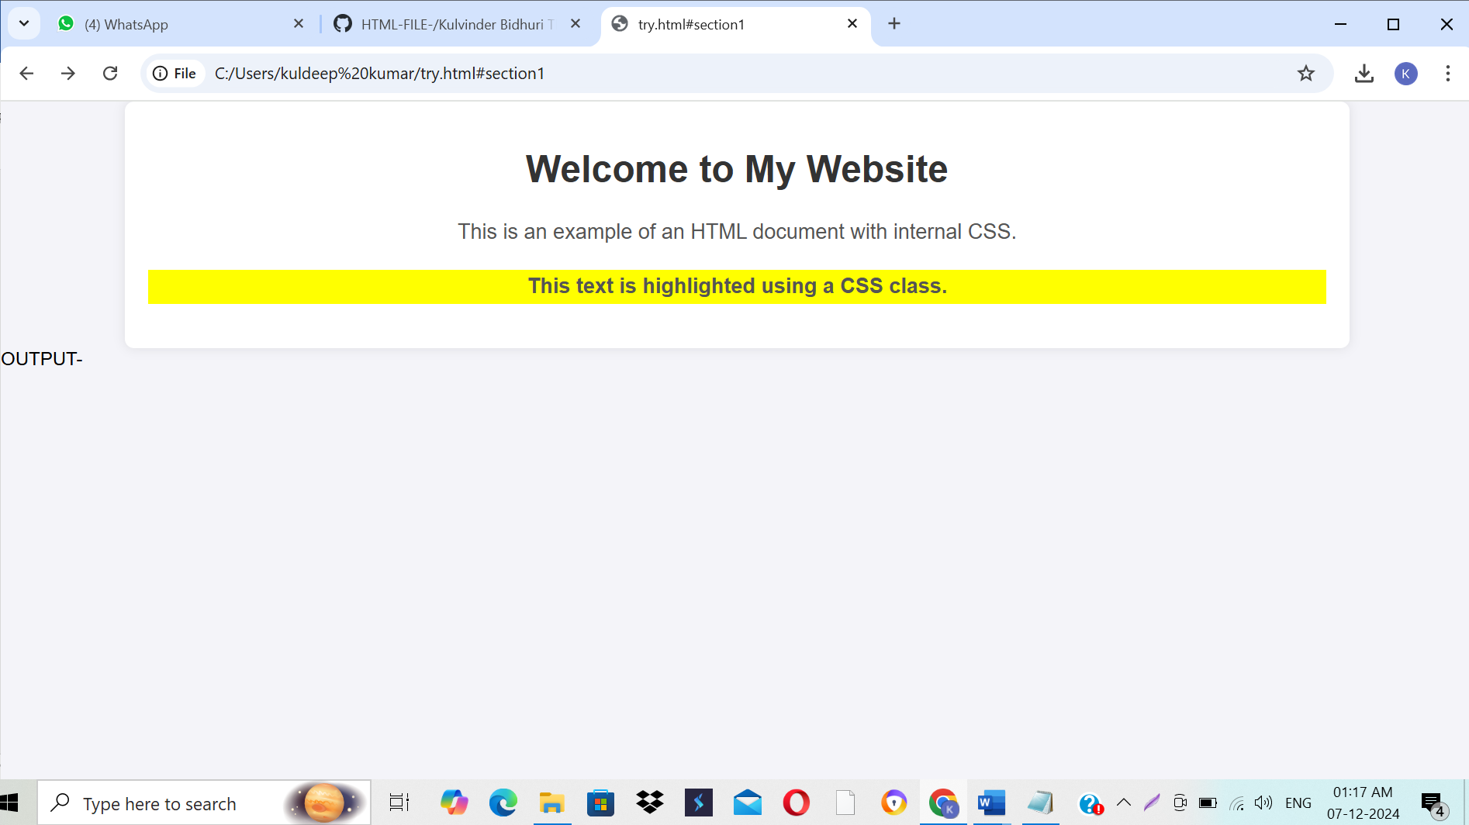

**Question 26) Write code to show Inline CSS with HTML code**

**INPUT-**

<html>

<head>

<title>Inline CSS Example</title>

</head>

<body>

<h1 style="color: blue; text-align: center;">Welcome to My Web Page</h1>

<p style="font-size: 18px; color: green; font-family: Arial, sans-serif;">This is a simple paragraph with inline CSS styling. You can apply styles directly within HTML tags using the "style" attribute.</p>

<div style="background-color: lightgray; padding: 10px; border-radius: 5px;">

<p style="color: darkred;">This div has a light gray background, rounded corners, and some padding.</p>

</div>

<button style="background-color: #4CAF50; color: white; padding: 10px 20px; border: none; border-radius: 5px; cursor: pointer;">

Click Me

</button>

</body>

</html>

**OUTPUT-**

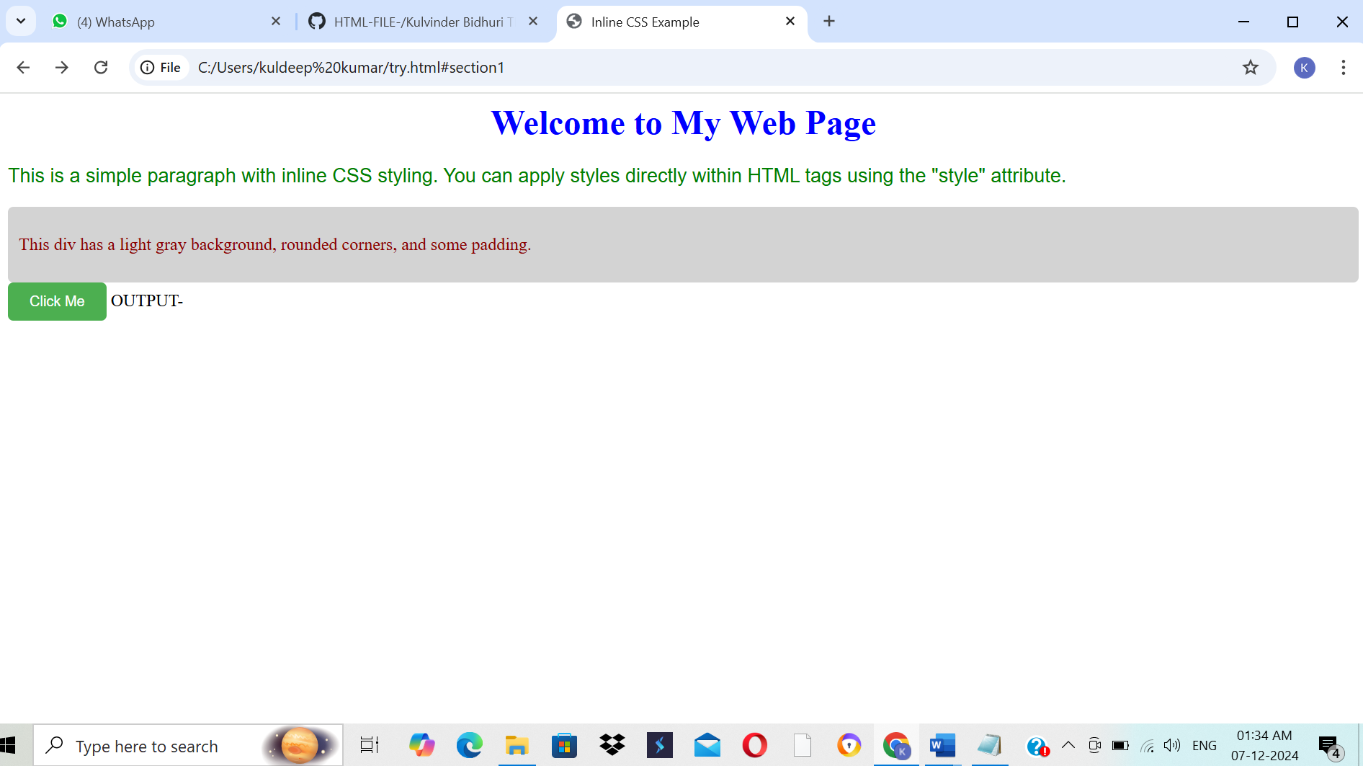

**Question 27) Write a program to add two numbers using form in JavaScript.**

**INPUT-**

<html>

<head>

<title>Add Two Numbers</title>

<script>

function addNumbers() {

const num1 = parseFloat(document.getElementById("num1").value);

const num2 = parseFloat(document.getElementById("num2").value);

if (isNaN(num1) || isNaN(num2)) {

document.getElementById("result").innerHTML = "Please enter valid numbers.";

} else {

const sum = num1 + num2;

document.getElementById("result").innerHTML = "Result: " + sum;

}

}

</script>

</head>

<body>

<h2>Add Two Numbers</h2>

<form onsubmit="event.preventDefault(); addNumbers();">

<label for="num1">Number 1: </label>

<input type="number" id="num1" required>

<br><br>

<label for="num2">Number 2: </label>

<input type="number" id="num2" required>

<br><br>

<input type="submit" value="Add">

</form>

<p id="result"></p>

</body>

</html>

**Output-**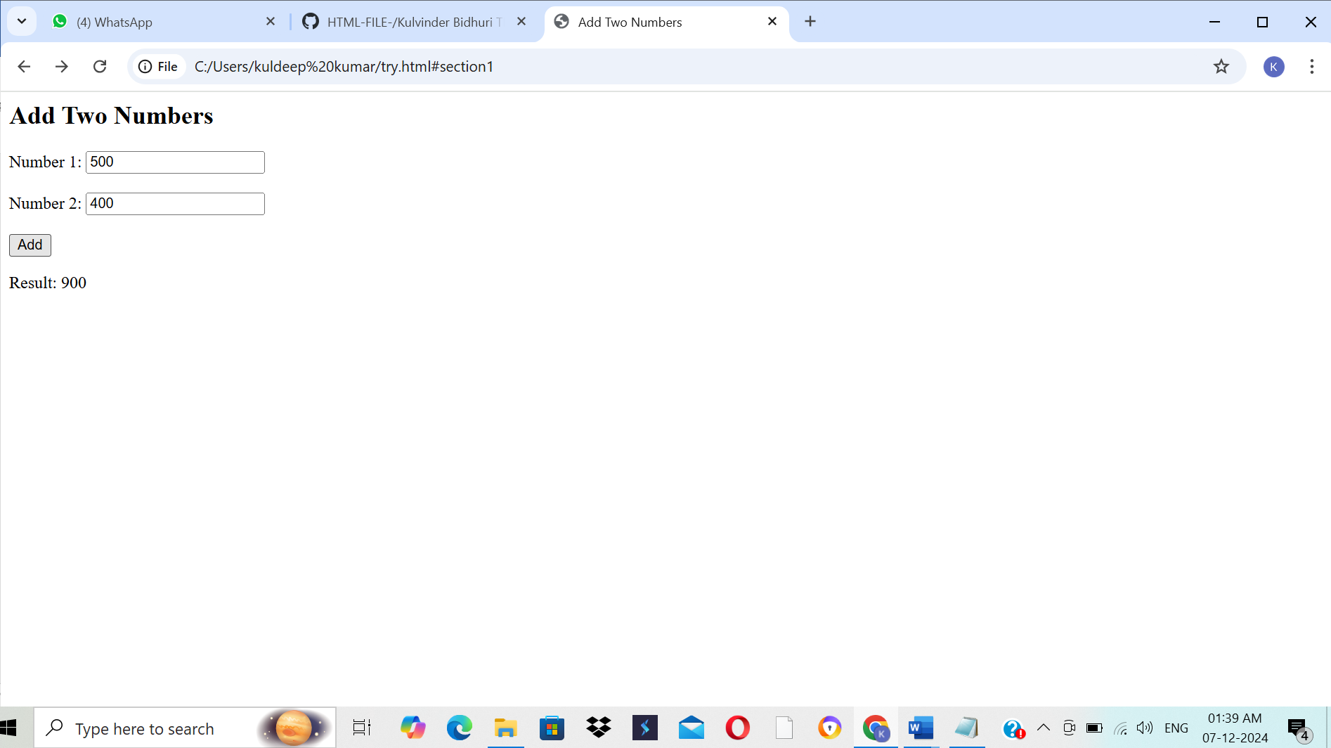

**Question 28) Write a program in JavaScript to swap two images using on mouseover event.**

**INPUT-**

<html>

<head>

<title>Swap Images on Mouseover</title>

</head>

<body>

<img id="image1" src="https://i0.wp.com/www.smartprix.com/bytes/wp-content/uploads/2024/05/A-2024-05-21T185632.262.jpg?fit=1366%2C768&ssl=1" alt="Image 1" width="500" height="500" onmouseover="swapImages()" onmouseout="resetImages()">

<img id="image2" src="https://i0.wp.com/www.smartprix.com/bytes/wp-content/uploads/2024/05/A-2024-05-21T185632.262.jpg?fit=1366%2C768&ssl=1" alt="Image 2" width="500" height="500" onmouseover="swapImages()" onmouseout="resetImages()">

<script>

function swapImages() {

var image1 = document.getElementById("image1");

var image2 = document.getElementById("image2");

var tempSrc = image1.src;

image1.src = image2.src;

image2.src = tempSrc;

}

function resetImages() {

var image1 = document.getElementById("image1");

var image2 = document.getElementById("image2");

image1.src ="Downloads/OIP (1).jpeg";

image2.src ="Downloads/OIP.jpeg" ;

}

</script>

</body>

</html>

**OUTPUT-**

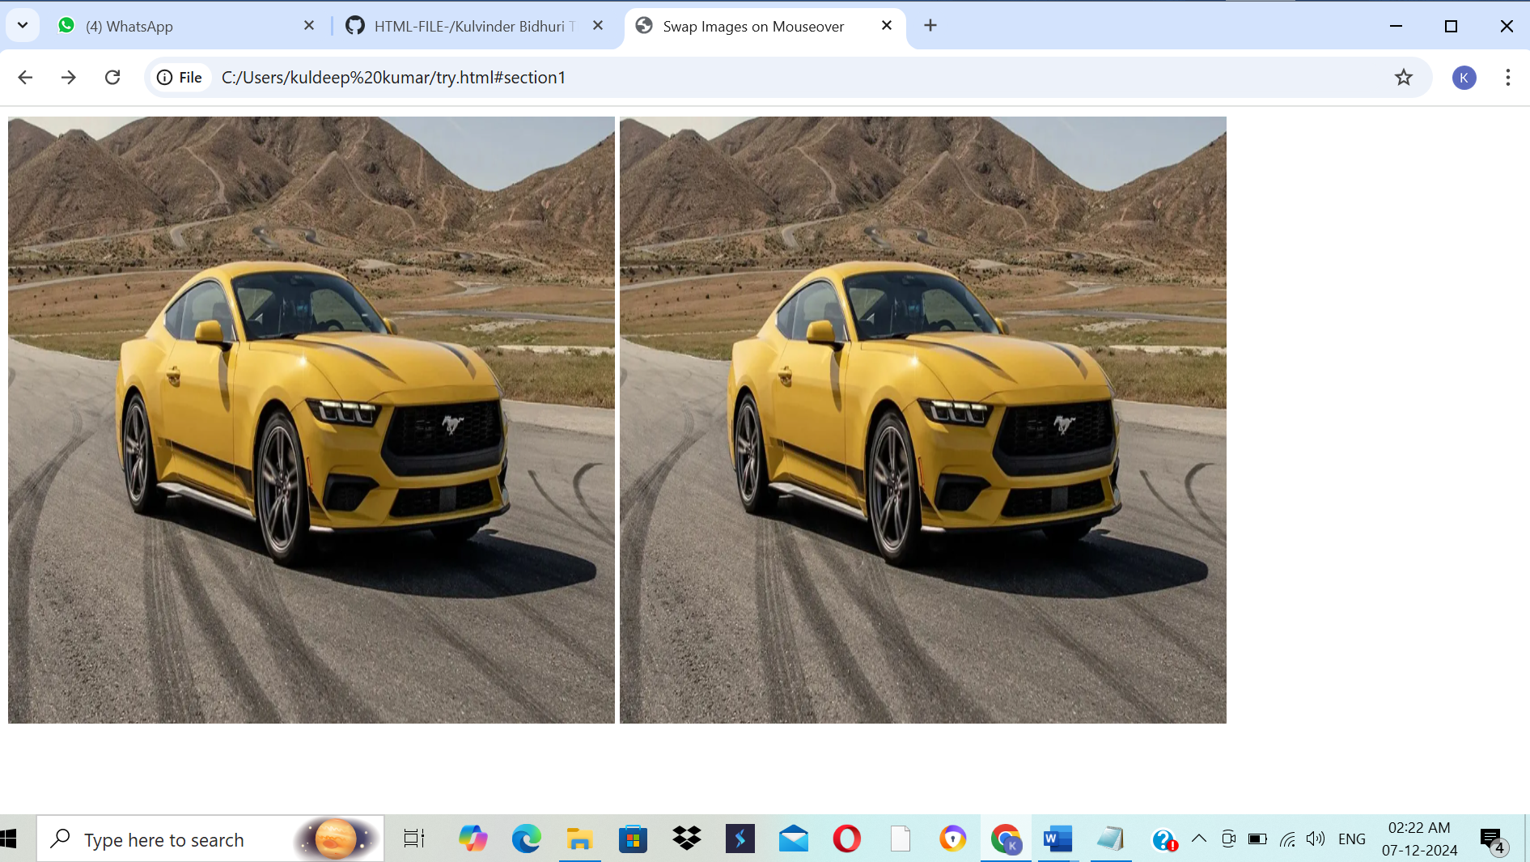

**Question 30) Write a JavaScript program to take as input three numbers from the user. Find the minimum and maximum of the three numbers. Print the following output in BOLD in the following format: MINIMUM = MAXIMUM =**

**INPUT-**

<html>

<head>

<meta charset="UTF-8">

<meta name="viewport" content="width=device-width, initial-scale=1.0">

<title>Find Minimum and Maximum</title>

</head>

<body>

<h2>Find Minimum and Maximum of Three Numbers</h2>

<label for="num1">Enter first number:</label>

<input type="number" id="num1" required>

<br><br>

<label for="num2">Enter second number:</label>

<input type="number" id="num2" required>

<br><br>

<label for="num3">Enter third number:</label>

<input type="number" id="num3" required>

<br><br>

<button onclick="findMinMax()">Find Minimum and Maximum</button>

<h3 id="output"></h3>

<script>

function findMinMax() {

const num1 = parseFloat(document.getElementById("num1").value);

const num2 = parseFloat(document.getElementById("num2").value);

const num3 = parseFloat(document.getElementById("num3").value);

if (isNaN(num1) || isNaN(num2) || isNaN(num3)) {

alert("Please enter valid numbers in all fields.");

return;

}

const minimum = Math.min(num1, num2, num3);

const maximum = Math.max(num1, num2, num3);

document.getElementById("output").innerHTML = `

<strong>MINIMUM = ${minimum}</strong> &nbsp;&nbsp;&nbsp;&nbsp;

<strong>MAXIMUM = ${maximum}</strong>

`;

}

</script>

</body>

</html>

**OUTPUT-**

